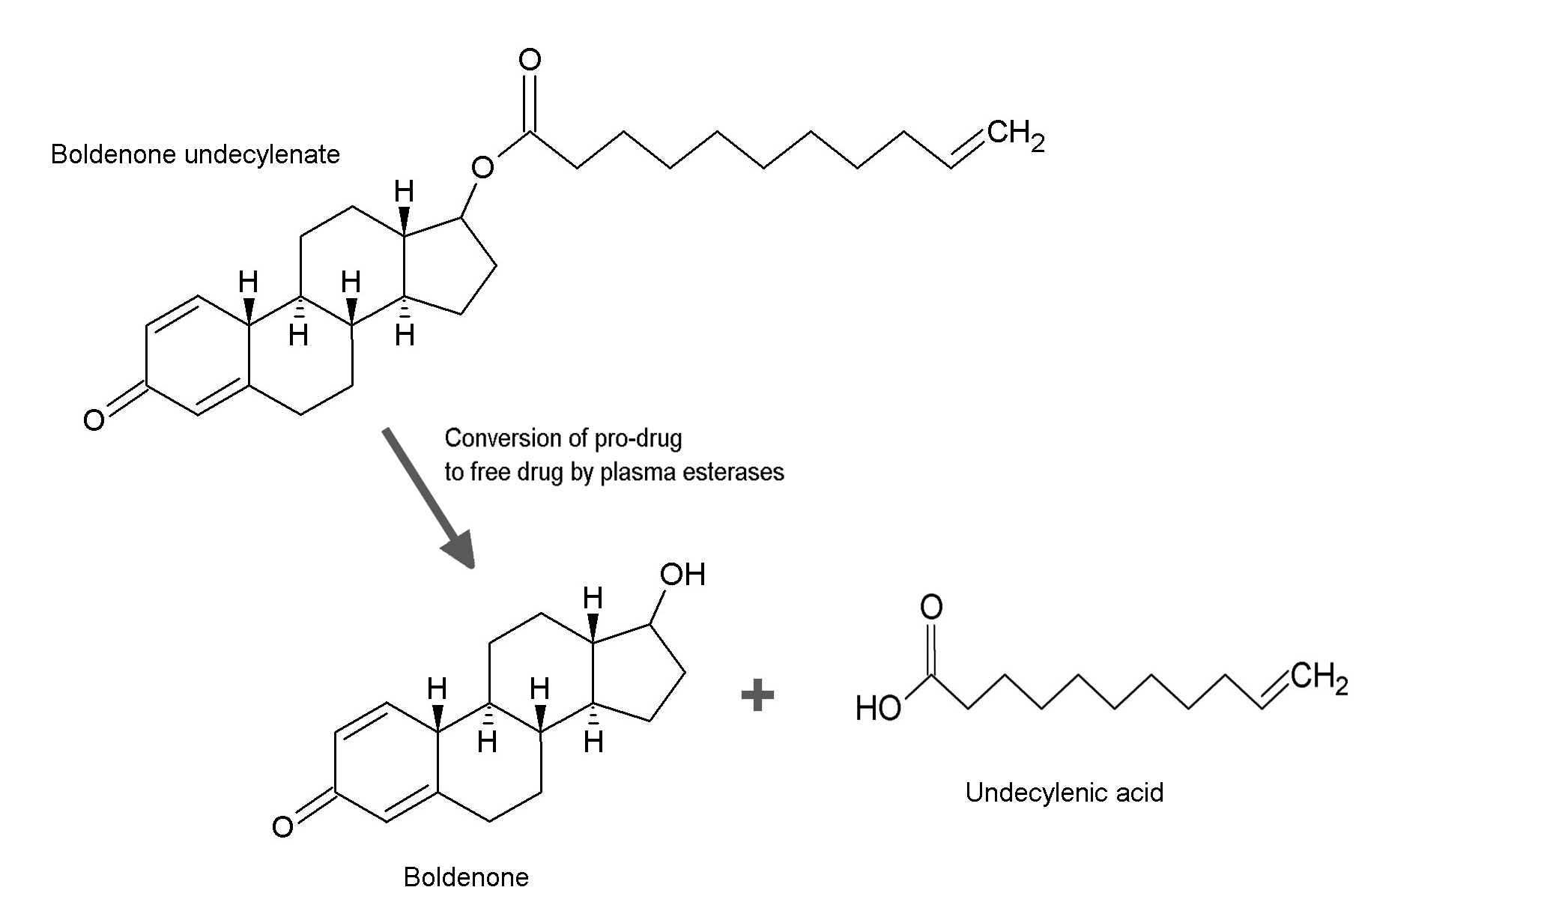

Long hydrocarbon chain of undecylenic acid makes the pro-drug soluable in oil.

